Employee Guide to Telework Approval

Table of Contents
Table of Contents 1
The Telework Journey 1
The Approval Journey - Six Steps to Telework 2
The Enterprise Telework Solution 3
Tile Telework Request Form 3
Guide to Individual Steps in the Approval Journey 3
Step 1 - Employee Interest Discussion 3
Step 2 - Employee Enters Request for Telework in ESS 4
Step 3 - System Confirmation of Employee Request 5
ATC Telework Request Denial 5
ATC Request Approval 6
Step 4 - Employee Acknowledges the Telework Management Directive 6
Step 5 - Employee Completes the Telework Agreement 7
ATC Agreement Completion and Revisions 8
Step 6 - Post-Approval Training 9

The Telework Journey
The purpose of this guide is to assist employees through the approval process. The process makes use of:
- An electronic routing system for telework approvals. This is known as the Enterprise Telework Solution (solution)
- Telework Agreements
- Discussions between employees and supervisors
This approval process is known as ‘The Telework Journey.’

The Approval Journey - Six Steps to Telework
The Approval Journey has six steps. Below is an image of the Six Steps to Telework communication you received. The image shows each step with a summary.
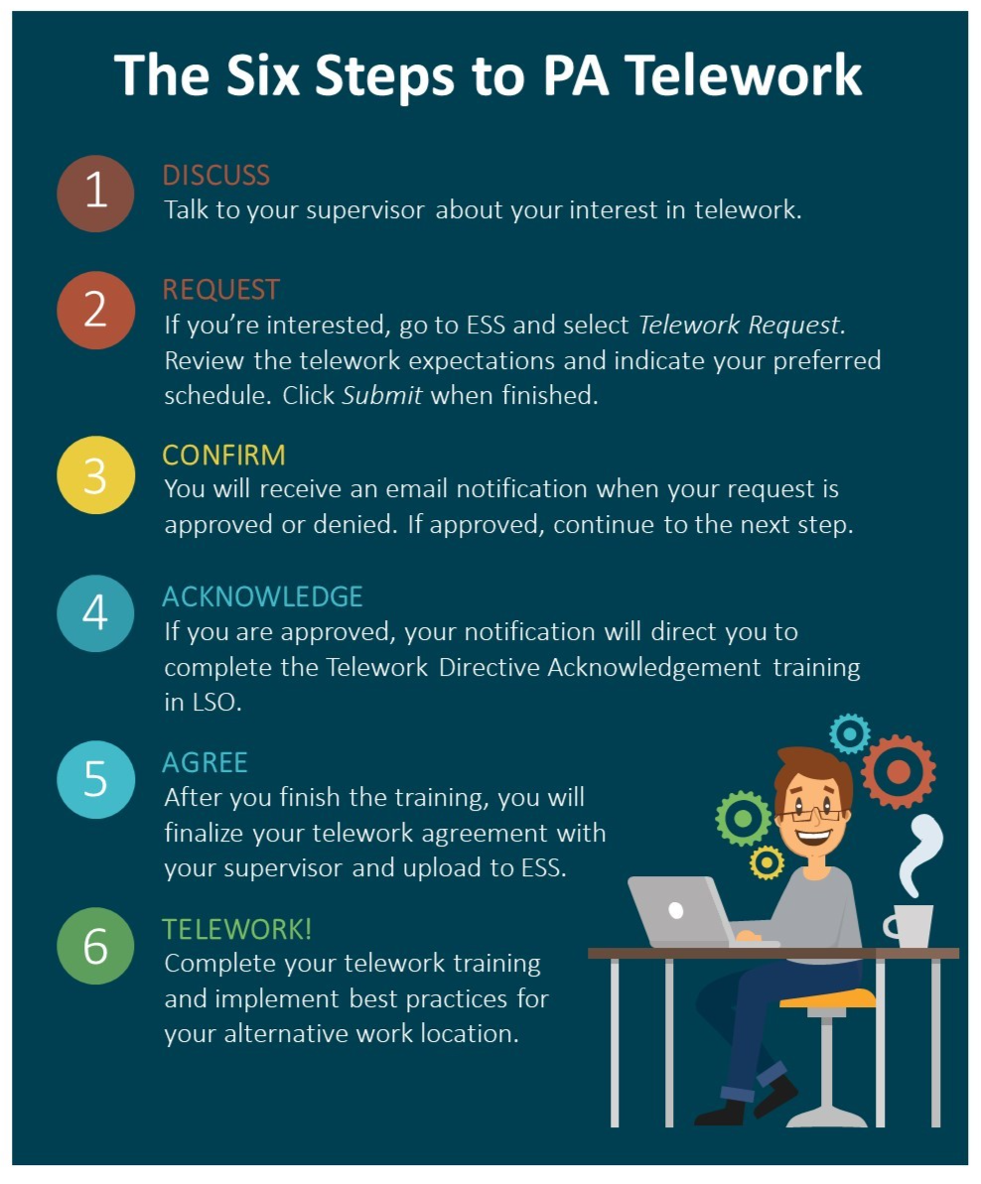

The Enterprise Telework Solution
To access and complete telework requests employees will need to access the Enterprise Telework Solution through Employee Self-Service (ESS). Employees will access the solution by clicking the ‘Telework Request’ tile grouped under the ‘Personal’ tiles. See image below.
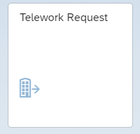

Tile Telework Request Form
After clicking the tile to access the solution, the employee will be directed to the following screen.
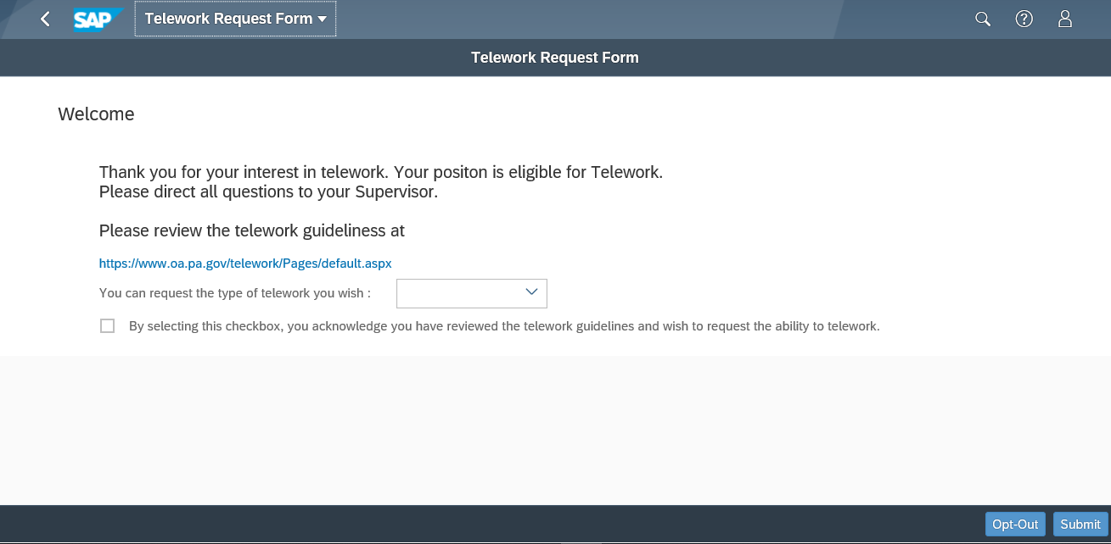
From this screen, employees can opt-out of telework, or complete and submit their telework requests. Employees will need to access this tile later in the Approval Journey to complete their Telework Agreement (Step 5).

Guide to Individual Steps in the Approval Journey

Step 1 - Employee Interest Discussion
Before employees access the ‘Telework Request’ tile to complete their requests, employees should discuss telework with their supervisor. During this meeting employees should discuss:
- Eligibility for their position
- Suitability criteria for program participation
- Telework schedule options that may be available to employees
- Telework resources such as the telework website, the Employee Guide to Telework Approval for reference and guidance, and the Telework Agreement.
A variety of scenarios may result from this discussion. Employees should ask their supervisor about the options available to them.

Step 2 - Employee Enters Request for Telework in ESS
In this step, the employee submits a telework request based on the discussion in Step 1. Employees will start the request by accessing the ‘Telework Request’ tile in ESS. See image of the tile below.
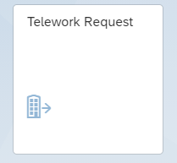
After accessing the tile, the employee will be directed to the ‘Telework Request Form.’ The employee will complete their request details at this screen.
Employees will need to review the telework guidelines by clicking the link. After reviewing the guidelines, the employee will select the type of telework schedule they wish from the drop-down menu. The options for telework types are part-time and full-time. Employees needing to request ad hoc telework should select the part-time option. The employee should select the type of telework based on their discussion with their supervisor in Step 1. Not all employees will be eligible or suitable for full-time telework. Please refer to the ATC or supervisor for guidance. The employee is required to select the check box before clicking the “Submit” button in the lower right corner. The employee will then confirm submission.
In the event an employee does not wish to participate in telework, the employee will simply select the “Opt-Out” button in the lower right corner. The employee will confirm the Opt-Out and the workflow will stop.
Once an employee has submitted a request form to participate or opt-out of telework, no changes to the request can be made. The employee will not be able to make a duplicate request. The tile will not be available for further action until the ATC has approved the telework request AND the employee has been assigned the Telework Qualification in Step 4. If the employee tries to re-access the tile, the following screen will be displayed.

Step 3 - System Confirmation of Employee Request
After an employee has submitted a ‘Telework Request Form’ the Enterprise Telework Solution will generate an email for both the employee’s immediate supervisor and the employee’s ATC. The subject line of the email will read “Employee full name personnel number Telework Request.” The email will note the name of the Enterprise Telework Coordinator (ETC), ATC, Supervisor, and Employee. The bottom of the email will indicate whether a request was made for telework or to opt-out of telework. A request for telework will prompt the supervisor to access their tile via ESS to add notes for the ATC to consider in their review of the request. The image below shows a sample email of a telework request.
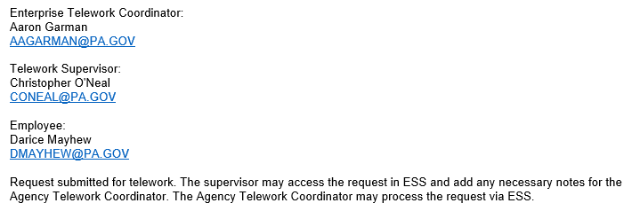
There will be a delay in receiving the notification from the solution.
Following the notification of an employee’s telework request, the ATC will review the request to determine if it should be approved or denied. The ATC will follow agency guidance relating to the Telework Management Directive, Telework Agreement, and their Agency Telework Plan in making the final determination to approve or deny a request.

ATC Telework Request Denial
If the ATC denies a telework request, the solution will generate a denial email sent ONLY to the employee’s supervisor. It is the responsibility of the supervisor to inform the employee making the request of their denial. The employee will not receive a denial notification. There will be a delay in receiving the notification from the solution.
A denial will stop the workflow and remove the request from the workflow process. The employee will not be able to submit a new telework request. If a new request is needed, the employee will need to contact their supervisor who should notify the ATC.

ATC Request Approval
If the ATC approves the employee’s telework request, the ATC will generate a notification that instructs the employee and their supervisor on next steps. The email will include a link to the appropriate Telework Agreement. The email will also direct the employee to search for the ‘Telework Acknowledgement’ training in LSO. These details will be displayed at the very bottom of the email underneath the names of the ATC, ETC, Supervisor, and requesting employee. The email below is a sample email with sample instructions. The approval notification email will display correct instructions for next steps.
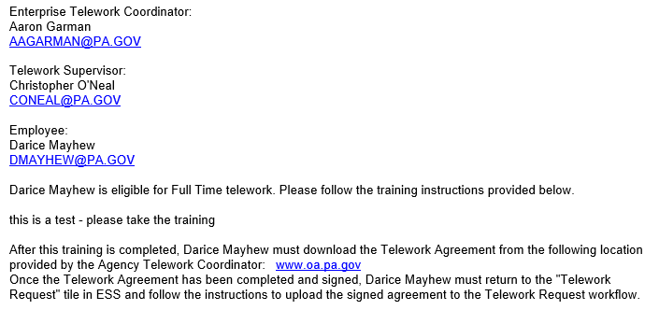
The email provides details on the employee’s name and type of telework request. It includes the training instructions and instructions on completing the Telework Agreement. There will be a delay in receiving a notification from the solution after ATC approval.

Step 4 - Employee Acknowledges the Telework Management Directive
The email notification to employees will instruct them to search for and complete the ‘Telework Acknowledgement’ training in LSO. After completing this training, SAP will assign a Telework Qualification to the employee in an overnight process. This qualification will indicate that the employee has completed the training. This step must be completed before Step 5. The employee will not be able to access the ‘Telework Request’ tile prior to completion. The workflow and telework request cannot be finished until the acknowledgement training has been completed.

Step 5 - Employee Completes the Telework Agreement
The employee will need to click on the link provided by the ATC in the approval email. The appropriate Telework Agreement must be downloaded to be filled out, saved, and uploaded back into the solution. Agreements are formatted as fillable PDFs. Supervisors should provide technical assistance to their employees, or direct them to the appropriate IT point of contact for ongoing technical troubles with the PDF. Employees should download and complete the following sections:
- Safety self-certification
- Alternate worksite details
- Telework Schedule details
- Electronically (digitally) sign and date for the employee
The Telework Agreement PDFs should be completed electronically with typed names as signatures. No printing, wet signatures, or scanning is necessary. Once completed, the employee should save the agreement. The employee will upload the partially completed agreement into the Enterprise Telework Solution. To upload the saved agreement, employees will need to access the solution through the ‘Telework Request’ tile under the ‘Personal’ tile groupings in ESS. This will not be possible until the completion of Step 4.
After accessing the tile, the employee will be directed to the ‘Telework Request Form’ where the menu title will read “Agreement and Guidelines” in the upper left corner.
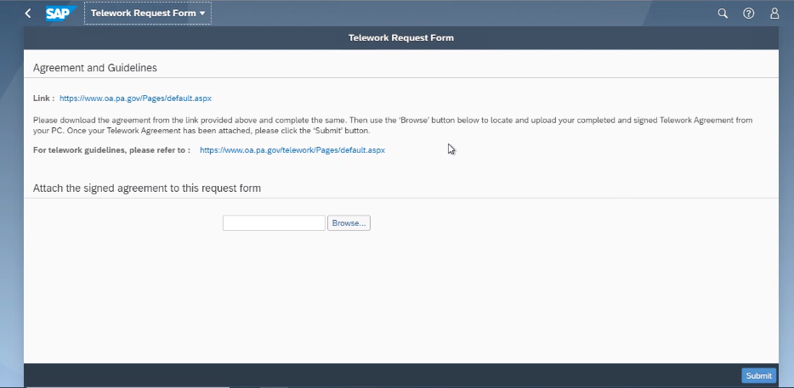
The link to the appropriate agreement can also be accessed on this screen. The employee will need to select the “Browse…” button and select their completed and saved agreement. Upon successful upload, the employee will select the “Submit” button in the lower right corner and confirm.
After the employee has confirmed the submission of their Telework Agreement, the solution will require the supervisor to review, sign, and submit a final Telework Agreement for the employee. If the employee’s saved agreement has errors, the supervisor should work with the employee outside of the solution to correct the agreement on the supervisor’s version before the supervisor uploads the agreement into the solution, when possible. During this time, the supervisor will discuss a potential telework start date with the employee-if this has not yet occurred. Once a start date is agreed upon by the supervisor and employee, the supervisor will submit the final Telework Agreement and the start date. The ATC will then review this submission.

ATC Agreement Completion and Revisions

ATC Completion
If the ATC confirms the Telework Agreement and the start date are completed accurately, the ATC will complete the telework request. The completion will generate a notification and the workflow will end. The email will list the ATC, the ETC, supervisor’s name, and the employee’s name. The bottom of the email will display the details for the employee’s request, start date, and “completed.”
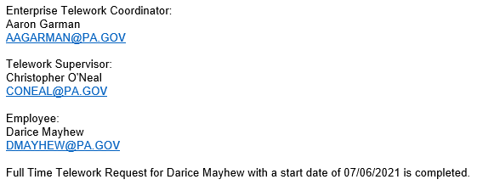
This will complete the workflow process and the completed agreement will move into the employee’s electronic official personnel file (eOPF). The “Telework Request” tile will remain visible to the employee. Access to the tile will be restricted, and the following screen will be displayed.

ATC Revisions
If the agreement, start date, or another problem is determined by the ATC, the agreement may be sent for revision to either the employee or the supervisor.
If the ATC sends the agreement to the employee for revision, an email notification will be sent to the employee and supervisor. Similar to other Enterprise Telework Solution emails, the details of the revision will be included at the bottom of the email. The employee should follow the instructions and repeat Step 5, making the necessary changes to the agreement before confirming submission. Once submitted, the supervisor will need to complete the agreement making any necessary changes to the start date. If more than one round of revisions is required, follow these directions until the ATC completes the request.

Step 6 - Post-Approval Training
After the ATC has completed an employee’s request for telework the employee will need to complete the mandated trainings. Employees will need to complete the ‘Teaming in Telework’ web-based training module in LSO. Employees should complete this training within three months of their approved telework start date.

